**The World Bank's international debt data**

The given text describes the purpose and scope of a data analysis project involving international debt data collected by The World Bank. The analysis aims to answer several questions related to the amount of debt owed by developing countries, such as the total amount of debt owed, the country with the highest debt, and the average debt owed by countries across different debt indicators.

This notebook will conduct an analysis of international debt data provided by The World Bank. The dataset contains data on the amount of debt owed by developing countries in various categories, measured in USD. Our analysis aims to address questions such as

* How much debt do the countries listed in the dataset owe in total?
* Which country has the largest amount of debt and what is the exact value of that amount?
* What is the mean amount of debt owed by countries for various debt indicators?

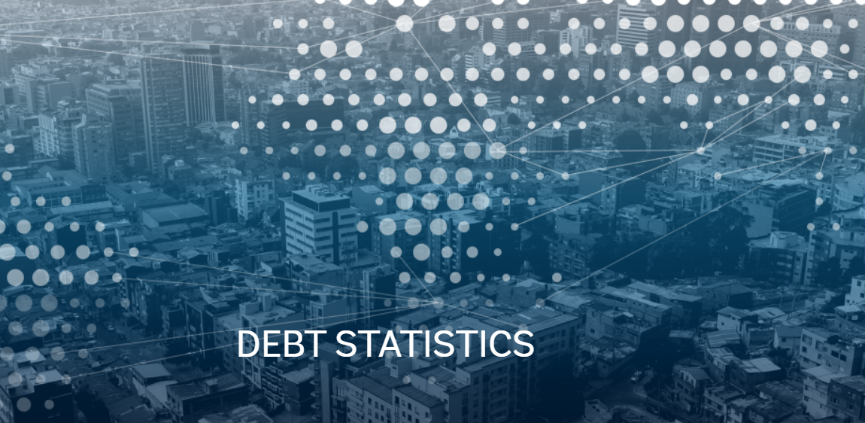

1. **Select all of the columns from the International Debt table Also .we’ll limit**

**The output to the first ten rows to keep the output clean.**

From the first ten rows, we can see the amount of debt owed by *Afghanistan* in the different debt indicators. But we do not know the number of different countries we have on the table. There are repetitions in the country names because a country is most likely to have debt in more than one debt indicator.

.

1. **Finding the number of distinct countries**[**¶**](https://sessions.datacamp.com/proxy/absolute/1e6669ad-ce5b-4b0c-ad5c-1ee032434d61/notebooks/production/users/2486100/i9v3igre70/notebooks/notebook.ipynb#2.-Finding-the-number-of-distinct-countries)

Finding out number of distinct countries help us to perform our statistical analyses holistically. In this section, we are going to extract the number of unique countries present in the table

It show that data set contain 124 unique countries .It help us in further analyzing there economic status.

1. **Finding out the distinct debt indicators.**

From above analysis we observe that there are 124 countries in total. In the first section, there is a column named "indicator_name" that provides a brief description of the reason for taking on the debt. Adjacent to that column, there is another column called "indicator_code" which represents the classification of these debts. Familiarizing ourselves with the different debt indicators can aid in comprehending the potential reasons why a country may have taken on debt.

There are total 25 different debt Indicator across which debt of 124 distinct countries are distributed.

1. **Totaling the amount of debt owned by the countries.**

As we all know the financial debt of a particular country represents its economic state.

Find out the total amount of debt (in USD) that is owned by different countries. This will give us a sense of how the overall economy of the entire world is holding up.

We have the exact total of the amounts of debt owned by several countries since debt is sum of different debts owned by countries across several categories.

1. **Country with the highest debt.**

Now understand more about the country in term of its socio economic scenario .

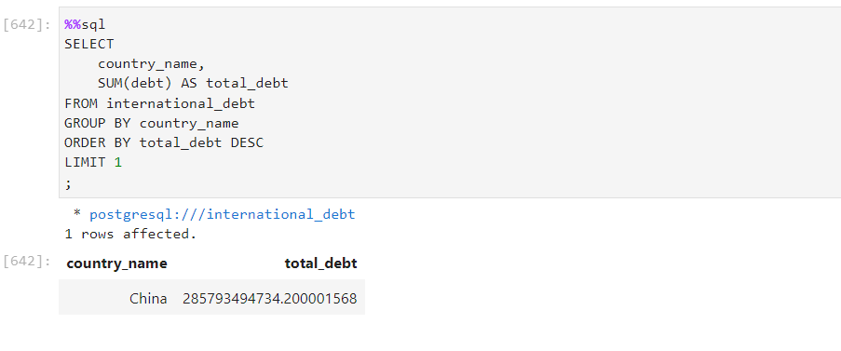

It has been established that China has own the highest debt. It can be validated with [world bank](https://datatopics.worldbank.org/debt/ids/country/CHN) website.

1. **Average amount of debt across indicators.**

After gaining a basic understanding of the dataset and its summary statistics, we can explore deeper to determine the average debt owed by a country. This will provide us with a clearer understanding of how debt amounts are distributed among various indicators**.**

The foremost debt indicator in terms of average debt is DT.AMT.DLXF.CD, which includes the repayment of long-term debts. Long-term debts are acquired by countries to obtain immediate capital. Further information regarding this category can be accessed through the provided resource.

A noteworthy observation from this discovery is the significant disparity between the amounts of the first two indicators, indicating that these categories may be the most severe in terms of countries' indebtedness

1. **The highest amount of principal repayments**

.To gain further insight, we can investigate which country owes the highest amount of long-term debt (DT.AMT.DLXF.CD). Since economic disturbances may affect countries differently, this finding will provide us with a more specific understanding of the economic situation of that particular country.

According to The World Bank, China holds the largest amount of debt in the long-term debt category. It's essential to verify our analyses to ensure their accuracy, and using credible sources such as The [World Bank](https://datatopics.worldbank.org/debt/ids/country/CHN) can help us achieve that.

1. **The most common debt Indicator.**

However, we need to investigate further to determine if long-term debt is the most prevalent form of debt owed by countries.

Dataset includes six debt indicators, including DT.AMT.DLXF.CD, suggesting that all countries in our dataset are facing a common economic challenge. However, this is just one aspect of the larger picture. Moving away from the debt indicators,

1. **Other viable debt issues and conclusion.**

let's focus on the maximum amount of debt owed by each country. This will help us identify other possible economic issues a country may be encountering. Throughout this analysis, we examined global debt levels and gathered various summary statistics to reveal intriguing facts and figures. Additionally, we verified our findings to ensure their accuracy.

